1. <https://www.youtube.com/watch?v=bhBSlnQcq2k>
2. Docker Runtime Environemnt.
3. 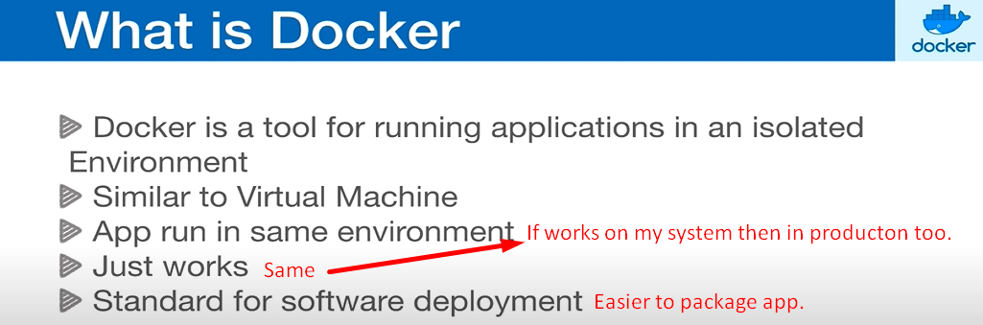
4. 